It’s Yoga Cincinnati
Winter/Spring 2027

RYT 200

Registered Yoga Alliance
Yoga Teacher Training Packet
Begins January 9–11, 2027

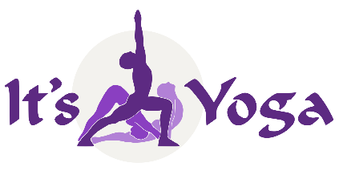

Thank you for inquiring about our Registered Yoga Alliance Teacher Training Program (RYT
200). It’s Yoga Cincinnati is the first Yoga Alliance Registered Yoga School (RYS) in Cincinnati. With over 26 years’ experience specializing in training yoga teachers. We are proud of our outstanding reputation for producing top-quality creative teachers who live and love the yoga lifestyle. Our graduates are highly sought after, teaching all levels of yoga at studios and gyms around the world.

Unlike most training programs that are limited to one style of yoga, our program offers training in two distinct but complementary traditional styles as well as introductions to Chair Yoga and Yoga Nidra:

- Ashtanga Vinyasa Yoga The most challenging style of classical yoga and foundation of
All Vinyasa, Power Yoga and Flow styles

- Hatha Yoga Individualized postural alignment as well as the
Traditional meditative style for any yoga level

These styles are presented so that the yoga teacher learns how to teach a challenging class for those who are ready, but also a less demanding class for beginners, senior citizens, or for those who prefer a more relaxed meditative approach.

We also emphasize a well-rounded introduction to all traditional aspects of yoga, including
techniques for meditation and pranayama (breathing exercises) as well as an intensive study of yoga philosophy (Patanjali’s Yoga Sutras), yoga theory, functional anatomy, fascia alignment, “Pure Movement Technology,” subtle anatomy, introduction to Ayurveda, English and Sanskrit asana terms and pronunciation.

A unique aspect of our program is the opportunity for practice teaching. Prospective teachers gain real practical experience by observing, assisting and teaching during public classes. This allows the prospective yoga teacher to gain experience and confidence in their teaching abilities. The program also offers nine months of free classes at It’s Yoga.

After you completed your RYT 200 training, we also offer an Advanced Training program for those who wish continue their training and earn a RYT 500 Certification, which qualifies you as a RYT 500 Professional Yoga Teacher.

If you are interested in our comprehensive yoga teacher training programs please submit the application form on page 11, including answers to the questions on page 12, along with your application fee. Feel free to contact me personally at (513) 300-5586 or itsyogaindu@earthlink.net if you have questions or need more details.

Indubala Bhardwaj, ERYT 500, T500, YACEP
A National Yoga Alliance Registered Yoga School RYS 200/300

What’s different about It’s Yoga Cincinnati’s RYT Yoga
Teacher Training Program?

It’s Yoga Cincinnati’s Teacher Training Program is scientifically designed by
experts and specialists who have harnessed the expertise of our Yoga Teacher Trainers in order to provide a full spectrum integrated approach to yoga postures, health, and traditional yoga lifestyle choices.

Level 1 RYT 200-Hours Certification

The 200-hour training is a time-tested program designed to enhance the overall health of the yoga practitioners by deepening and refining the layers of their yoga practice. Set yourself apart from other yoga teachers by learning skills that will proactively protect against physical and mental injury using Pure Movement Technology as well as learning to lead a professional, safe and effective yoga class.

This customized program is an integrative approach that focuses on the new anatomic approach we call “Pure Movement Technology” the study of asanas based on Function, Tensegrity, Fascia Alignment, Biotensegrity and Integrated Movement. Emphasis is placed on both physical and psychological benefits and developing a balance between strength, stability and range of joint motion. Personal empowerment lifestyle models are presented allowing trainees to explore various traditional yoga methods that can be used to harmonize the body, mind and spirit.

Standards are enhanced in preparation for professional level training (RYT 500) by the introduction of Raja Yoga, Yoga Philosophy, Sanskrit terminology & pronunciation, Yoga Technology and Ayurveda. We use a variety of visual aids based on: skeletal models and the study of common movement patterns that tend to result in repetitive stress injury.

Students learn to conduct classes in several styles such as Hatha, Modified Ashtanga and Vinyasa Yoga so that trainees can modify their teaching repertoire according to current demands of various yoga studios. Class observations and practice teaching requirements help trainees develop experience and confidence in their teaching skills before completing the program. Nine months of free classes gives the trainee ample opportunity to improve their practice and observe experienced RYT teachers.

RYT 200 Program Content:

Functional Anatomy - bones, joint capsule mobility, common asana problems & mechanics
Pure Movement Technology and Integrated Movement – includes study of joint movement and the effects of fascia, spinal tensegrity, muscle chains and compensation patterns
Therapeutics - - - postural diagnostics, body reading, correcting common posture problems and introduction to yoga as therapy
Posture Adjustment Techniques - - - verbal cues & physical (2 finger) gentle adjustments
Asana Technique - - - moving from the center, joint integrity, improving range of movement (ROM), posture benefits, contraindications & aligning the energy pathways (nadis)
Raja Yoga - - - meditation techniques, Yoga Sutras & Yoga Philosophy
Pranayama - - - ujjayi breathing, 5 prana vayus, 5 Bhuta, subtle anatomy & chakras
Sanskrit - - - popular terminology, asana pronunciation
Theory - - - tristana, gunas, drishti, importance of bandhas in postural alignment
Yoga Tradition - - - history of yoga, lifestyle, introduction to Ayurveda & Ancient Sankhya Yoga Theory
Teaching Methodology - - - practice teaching and cueing, class observation & assisting,
Ethics - - - psychology of teaching, student-teacher relationships & marketing

9 Months of Free Classes for all trainees

It’s Yoga requires a minimum of 90 hours of yoga class attendance during training up through 9 months to be eligible for certification. This way yoga trainees become exposed to a variety of yoga class styles, teaching methods and teachers. If you live at a distance we will help you to work out an alternate method of class attendance.

Eligibility is open to any sincere yoga student who has practiced yoga in a studio and thirsts for a deeper understanding of the science and tradition behind asana practice. You must also be at least eighteen years of age. With a few exceptions, we require full attendance during teacher training weekends. Missed time and material must be made up!

Required Reading during Teacher Training (books included with tuition)
1. It’s Yoga Cincinnati Teacher Training Workbook & Technique Manual, by Indubala Bhardwaj,
ERYT500, T500, YACEP
2. Functional Anatomy of Yoga, A Guide for Practitioner’s and Teachers by David Keil
3. The Yoga Sutras of Patanjali – an accessible commentary by Kurt Matthys

Financial Arrangements & Payment Plans are available (see page 10) Questions? contact Indu Bhardwaj at 513-300-5586, text or email itsyogaindu@earthlink.net

Training Dates are listed on page 11

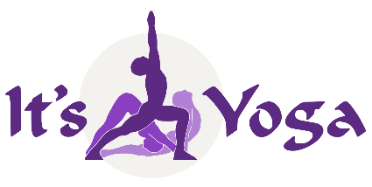

RYT 200 Yoga Teacher Training Graduation Requirements

1. 200 + Training Hours
● Technique: 105 contact hours + 15 non-contact hours = 120 total hours
● Yoga Philosophy: 30 contact hours + 5 non-contact hours = 35 total hours
● Anatomy: 15 contact hours + 10 non-contact hours = 25 total hours
● Teaching Methodology: 25 contact hours = 25 total hours
● Practicum; 10 contact hours + 11 non-contact hours = 21 total hours
● Electives: 30 non-contact hours = 30 total hours

Note: Contact hours required to be under direct supervision of the Primary ERYT 500 Lead Trainer

2. Homework Assignments
● Reading and Written assignments from the Teacher Training Workbook & Technique Manual
● Script development
● Asana Flash Cards + Benefits & Sanskrit Pronunciation
● Teacher Training participation & 90 hours yoga class participation
● Reading assignments: Technique Manual, Workbook, Functional Anatomy & Yoga Sutras
● Observing a minimum of 2 yoga classes between sessions

3. Examinations (passed with a score of 70% or above)
● Functional Anatomy Exam
● Yoga Theory & Philosophy Exams
● Yoga Technique Exam
● Practical Examination

NOTE: 90 hours of open class attendance is required for graduation. (Contact Indu at
513-300-5586 if you live out of town)
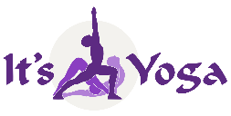
Yoga Teacher Trainers

No yoga teacher training program attains excellence without a
dedicated and highly experienced director & staff
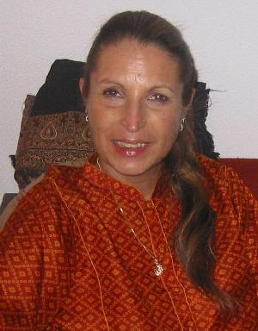

Indubala Bhardwaj, MT, ERYT 500, T500, YACEP
Experienced Professional Yoga Teacher & Lead Trainer
RYT 200/300 Teacher Training Program Director

Indu’s has been teaching yoga in Cincinnati since 1980. She began her yoga practice in 1968, after meeting Swami Satchidananda.

After a career in classical ballet, she studied Medical Massage Therapy at the Canadian College of Massage and Hydrotherapy, obtaining her license in 1974. Indu met her mentor, Pundit Yogi Raj Sharma Shastri in 1976. With him she studied Yoga Philosophy, Sanskrit, and Brahm Vidya Shastra for 22 years. In 1985 she was initiated into the Mahanubhava Marg by the Late Rajdhar Baba of the Samvatsar Ashram in Maharashtra, India. From 1980–1991, Indu was one of the founding fathers of Cincinnati’s first Hindu Temple in Cincinnati. She served as a Board Member, holding several offices as well as being the Vice President and Editor of the temple’s newsletter, Aradhana.

Indu co-founded the first yoga studio in the Tri-State Area (Cincinnati Yoga School) in 1998. Then, in 2000, she co-founded It’s Yoga Cincinnati, RYS 200 & 300, the first Yoga Alliance Registered Yoga School to train yoga teachers in the TriState area.

Though Indu also teaches yoga classes and workshops, she has specialized in training yoga teachers for the past 26 years. On October 2016, she was honored by the Cincinnati Yoga Teachers Association with a Life-Time Achievement Award presented by The Mayor of Cincinnati and Cincinnati’s sister city, Mysore, India.
Indu is an expert in yoga myofascia anatomy, inspired by her background in movement and massage, along with her studies with Doug Keller in “Yoga as Therapy” and with Thomas Meyers in “Fascia Alignment”.

Being an avid student of intelligent pure movement and integrated anatomy, Indu helps yoga students learn how to approach postures with ease and awareness, while at the same time incorporating breath, bandhas and drishti. She believes in living a yoga lifestyle both on and off the mat, best defined in The Bhagavad Gita as “skillfulness in action.”

Certifications
RYT 500 Hatha Yoga, Pranayama & Meditation Integral Yoga
RYT 200 Ashtanga Yoga & Rocket Yoga It’s Yoga San Francisco – Larry Schultz
RYT 300 Swastha Yoga & Ayurveda Ganesh Mohan
RYT 148 Yoga as Therapy Doug Keller
RYT 150 Raja Yoga Integral Yoga
RYT 80 Yin Yoga Paul Grilley
RYT 75 Cardiac Yoga Integral Yoga

Additional Training & Workshops
Certified M.S. Yoga Instructor National Multiple Sclerosis Society
Certified in Pilates & Allegro Reformer Twenty First Century Pilates Training
Certified Fitness & Aerobics Instructor Exercise Science Alliance
Pattabhi Jois Ashtanga Vinyasa
Richard Freeman Ashtanga Vinyasa
David Williams Ashtanga Vinyasa
Kino MacGregor Ashtanga Vinyasa
David Kiel Mysore Style Ashtanga
John Coon Vinyasa Krama
Srivatsa Ramaswami Vinyasa Krama
Thomas Meyers Fascia Anatomy, Movement
Vyaas Houston (American Sanskrit Institute) Sanskrit 1-3 levels
Julie Cordier & Johanna Wilt (BodyMind Balance) Gyrotonics & Power Pilates (14 years)

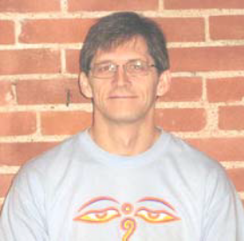
Kurt Matthys, BA, ERYT 500, T 500
Experienced Professional Yoga Teacher & Trainer

Kurt has studied, practiced, meditated and lived the “yoga lifestyle” for the past 23 years. As a true yogi who lives a life of inspiration both on and off the mat, Kurt has trained in many styles of yoga: Ashtanga Vinyasa, Kripalu, Integral Yoga, Hatha, and Vinyasa Krama. His primary focus is Ashtanga Vinyasa. He has mastered the 1st & 2nd Ashtanga Series and continues to work on the 3rd Series.

An enthusiastic lecturer and teacher of yoga asanas, Kurt loves introducing yoga teacher trainees to Sanskrit and yoga philosophy. Kurt’s personal teaching style encourages students to “Focus on the present and be open to change.” He believes in having fun while, at the same time, he teaches his students to flexible enough to accept new challenges. Kurt emphasizes the importance of students developing their own daily yoga practice.

For years Kurt has been an enthusiastic student and teacher of Yoga philosophy. He first started studying Indian yoga texts privately with Indu Bhardwaj, and continues to study the Yoga Sutras in both Sanskrit and English. In 2022 Kurt’s studies culminated in his authoring of the book The Yoga Sutras of Patanjali, an Accessible Commentary. In this important book Kurt explains, in easy-to-understand words, what Yoga Sutras of Patanjali is and is not. He provides the original Sanskrit, its transliteration and translation, and a commentary on each sūtra. His book serves as an accurate bridge, preparing beginning students for later study of more advanced yoga philosophy books.

A Computer Systems Architect with Fifth Third Bank until his retirement in 2020, Kurt also enjoys woodworking and Kirtan (singing sacred Sanskrit songs). In January, 2016, Kurt was featured as “The Yogi” in Cincinnati Magazine’s article “Secrets of the Super Fit.”

Certifications
RYT 500 Ashtanga Vinyasa, Hatha & Pranayama It’s Yoga Cincinnati
RYT 40 Yin Yoga Paul Grilley
RYT 60 Introduction to Sanskrit Indubala Bhardwaj

Additional Training & Workshops
Vicky Sorenson Ashtanga Vinyasa
David Swenson Ashtanga Vinyasa
David Williams Ashtanga Vinyasa
Larry Schultz Ashtanga Vinyasa & Rocket Yoga
Doug Swenson Vinyasa/ Soft Form
Srivatsa Ramaswami Vinyasa Krama
Pundit Rajmani Tigunait Tantra (Himalayan Academy)
David Frawley Ayurveda & Yoga
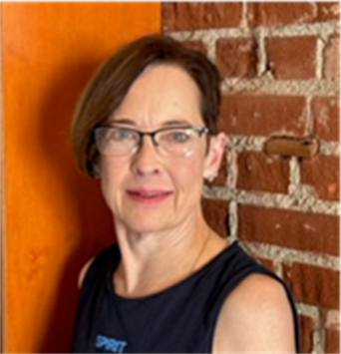
Letty Reifel Hater, BS, MEd, RYT 500
Experienced Professional Yoga Teacher & Trainer

Letty is a Registered Advanced Level Yoga Teacher (RYT 500) as well as a valued teacher of several classes at It’s Yoga Cincinnati. Letty is trained in Hatha, Vinyasa, Ashtanga, Yin, Subtle, Restorative and Chair Yoga. She initially began her yoga journey with an interest to keep active. Yoga seemed the perfect answer to finding balance and an increased connection to herself. A lifelong learner, she soon sought to deepen her knowledge of yoga by exploring other forms of yoga through certifications and participating in various workshops with Kino MacGregor and others.

In her earlier life, Letty was immersed in the martial art of Tae Kwon Do (TKD). She attained the rank of 4th Degree Black Belt (Kukkiwon Certification), becoming an advanced TKD instructor and a Pan American International Referee of the sport. In 1988 she was invited to become a member of the Olympic Woman’s TKD demonstration Team in Seoul, Korea. She was also nominated as the AAU Athlete of the Year as a result of being a champion of numerous national, state and local competitions in Kata (detailed choreographed patterns of martial arts movements practiced alone) and in Kumite (training against an adversary).

She served the city of Cincinnati for 32 years as the first female drafts‘man’ in the City Engineering Department, later becoming the Operations Manager of Cincinnati’s parking facilities. Along the way, while supporting a family, she earned BS and M.Ed. (Adult Learning) degrees from Xavier University.

Her life inspiration comes from a verse in the Srimad Bhagavad Gita: “Yoga is the journey of the self, to the self, through the self.” Letty invites you to travel along with her on your personal yoga journey at It’s Yoga.

Certifications
RYT 500 Ashtanga, Vinyasa, Hatha & Pranayama It’s Yoga Cincinnati
RYT 30 Yin Yoga Immersion 1, 2 & 3 Matt Eshelman
RYT 20 Anatomy of Yoga Frik Shun, Yoga & Coaching

Education, Additional Training
Tae Kwon Do 4th Degree Black Belt Kukkiwon Certification
Jivamukti Kino MacGregor
Ashtanga Primary Series Kino MacGregor
Osteoporosis: Health Lifestyle Stategy for Fitness Professionals Dr. Schott W. Sheatham PhD DPT
Evolution of Breath Work Neuropeak Pro Breath
Chair Yoga & Subtle Body Day Yoga, Dayton OH.
Yin & Subtle Body Gota Cebrero Ashville Yoga Center

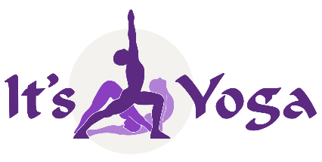
200-Hour Weekend Yoga Teacher Training
Payment Plans – 2027

Option #1:
Pre-payment Special to be paid before January 1st
Paid in-full $2,750 (early bird $100 discount, no registration fee)

Option #2:
$500 registration fee (due before January 9th)
$2,350 Balance Due on or before 1st session
Total payment $2,850

Option #3:
$500 registration fee (due before January 9th)
$480 5-Session payment plan (payments 2nd through 7th sessions)
Total payment: $2,900

Option #4:
$500 registration fee (due before January 9th)
$312.50 8-Session payment plan (payments 2nd through 9th sessions)
Total payment: $3,000

Free unlimited 9-month TT Class Pass begins upon receipt of the $500 Registration Fee

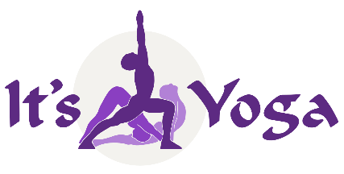

It’s Yoga Cincinnati

RYT-200 RYT Yoga Teacher Training Application 2027

Name __________________________________________________________ Date_______________________
Address _____________________________________________________________ Apt _________________
City __________________________________ State _________ Zip ______________________
Phone Numbers: Cell _______________________ Date of Birth: ________________________
Email ________________________________________
Referred By___________________________________

RYT 200 hour 2027 Dates: Nine Weekend Sessions over Six Months

Session #1 January 9 – 10, Session #2 Jan. 23 – 24, Session #3 Feb. 6 - 7, Session #4

Feb. 20 – 21, Session #5 March 6 – 7, Session #6 March 20 – 21, Session #7 April 10 – 11,

Session #8 April 24 – 25, Session #9 May 15 – 16

(Written & practical exam dates to be determined during the 9th Session)

- Deposit of $500 must accompany application to reserve your space
- A full refund (minus $75 processing free) will be returned if withdrawal occurs before start date
- There are no refunds for previously attended sessions
- Training Materials must be returned upon withdrawal

I understand and accept these terms and agreements.

________________________________________________ _____________________________
(Signature) (Date
Application Form (continues on page 12)

Please answer the following questions along with your application form:
How long have you studied yoga and what styles have you practiced?
What teachers have influenced you the most?
If you teach, how long have you been teaching?
Do you practice meditation and pranayama? Explain.
Have you studied any yogic texts? Which ones?
Why do you wish to train with It’s Yoga Cincinnati?
What do you hope to gain from this training?
How did you find out about this training?
List prescription medications or special diet that you may be using during training.

List all physical limitations & injuries, including pre-existing condition

